 | 20th International Biennial Neuman Systems Model Symposium  June 20, 2025 - Virtual  (1800-2200 Netherlands; 1200-1600 Eastern; 0900-1300 Pacific)

“Perspectives on the Integration of the Neuman Systems Model and Technology in Modern Healthcare”

Keynote Speaker: Jonathan Bayuo, PhD, RN, MACN, FFNMRCSI
Clinical Fellow & Research Asst. Prof, School of Nursing, The Hong Kong Polytechnic U.
Adjunct Scholar, School of Nurs. & Midwifery, U of Health & Allied Sciences, Ghana
Fellow, Center for Nursing Philosophy, Sue & Bill Cross School of Nurs., U of Calif., Irvine

Dr. Bayou is a Registered Nurse specializing in burns, plastics, and reconstructive surgical nursing alongside postgraduate training in gerontology. Currently, he works at the School of Nursing, The Hong Kong Polytechnic University as a Research Assistant Professor concurrently with an adjunct role at the School of Nursing and Midwifery, University of Health and Allied Sciences, Ghana. Dr. Bayuo maintains active clinical practice, research, and teaching across both undergraduate and postgraduate levels. Apart from empirical research, he remains active in philosophical discourses. | 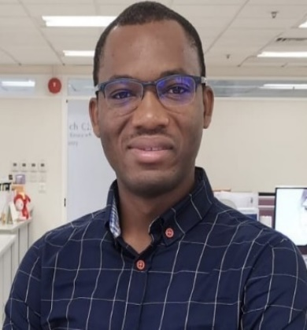

Symposium Objective:  - To explore the intersection of technology in modern healthcare and the Neuman Systems Model.  Keynote Address:  - Integrating Technology in Modern Healthcare: Philosophical and Practical Perspectives with a Focus on the Neuman Systems Model  Roundtable Discussions:  - Integrating AI into the Neuman Systems Model: Enhancing Holistic Health Care  - Addressing the Challenges of Asylum Seekers in the Netherlands through the Neuman Systems Model | Podium Presentations:  - Efficiency of the Neuman Systems Model: Elder Care in Long Term Memory Care  - The Neuman Systems Model in Technology-Driven Spiritual Care for Older Thai Adults with Depression  - Strengthening Nurses’ Lines of Defense: A Neuman Systems Model-Guided Framework for Addressing Workplace Violence Reporting  - Optimizing Patient Flow: Throughput Coordinators and Strategies for Enhanced Efficiency  - The Electronic Health Record and Documentation Burden: Evaluating California Nurses’ Experiences

All sessions will be presented in Zoom meeting format. Certificates of attendance will be available following the symposium. Registration information ($30 USD) is available through the link to Eventbrite on the Neuman website at www.neumansystemsmodel.org.

